**ALICE 3: PRACTICE AND PROJECTS :**

* P . Harsha Vardhan reddy

192311078

SECTION 2_1 PRACTICE:

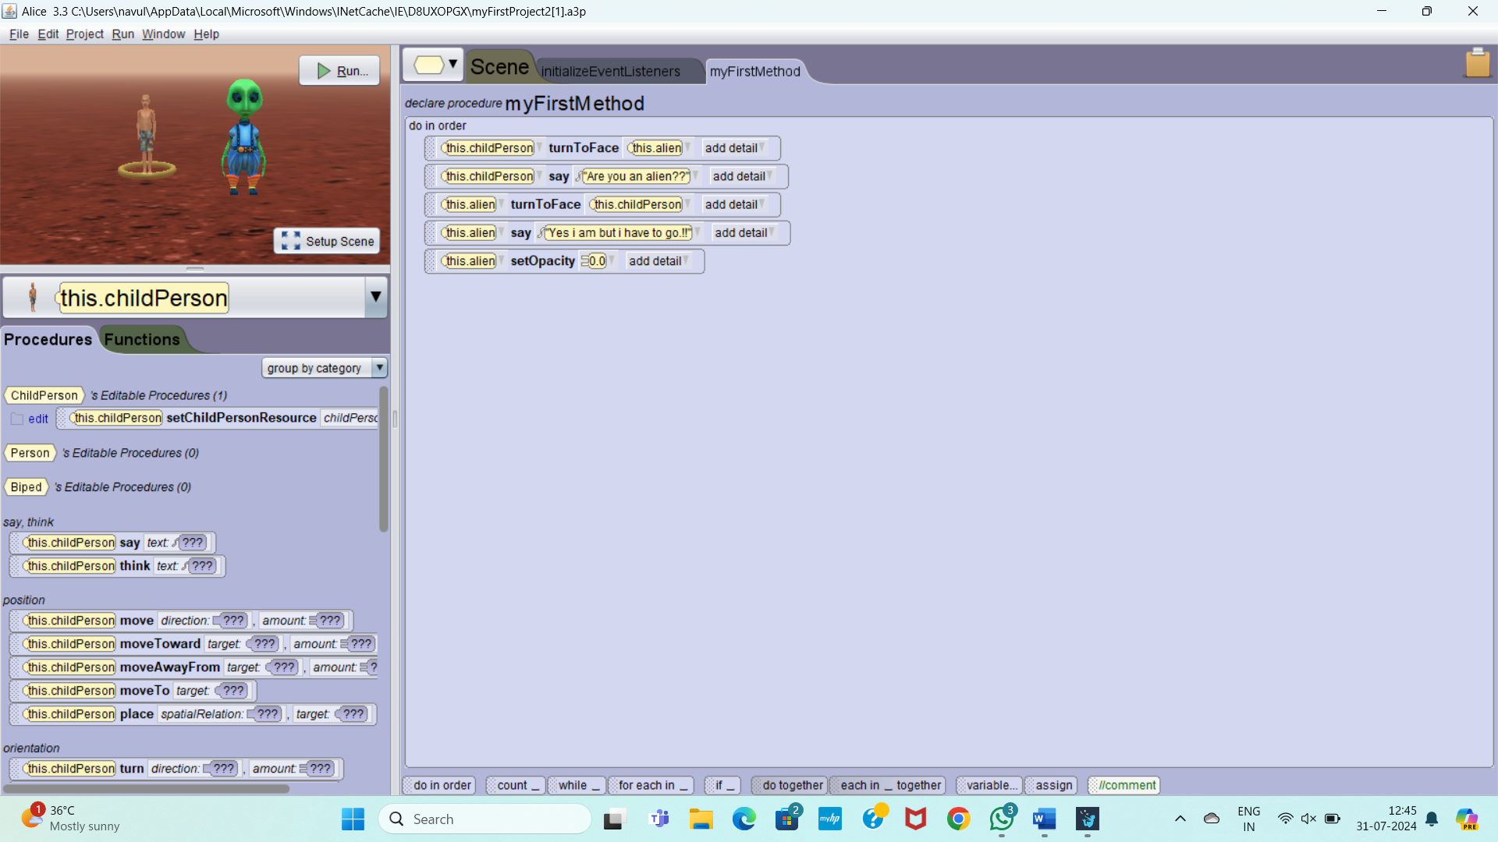

2_1 PROJECT

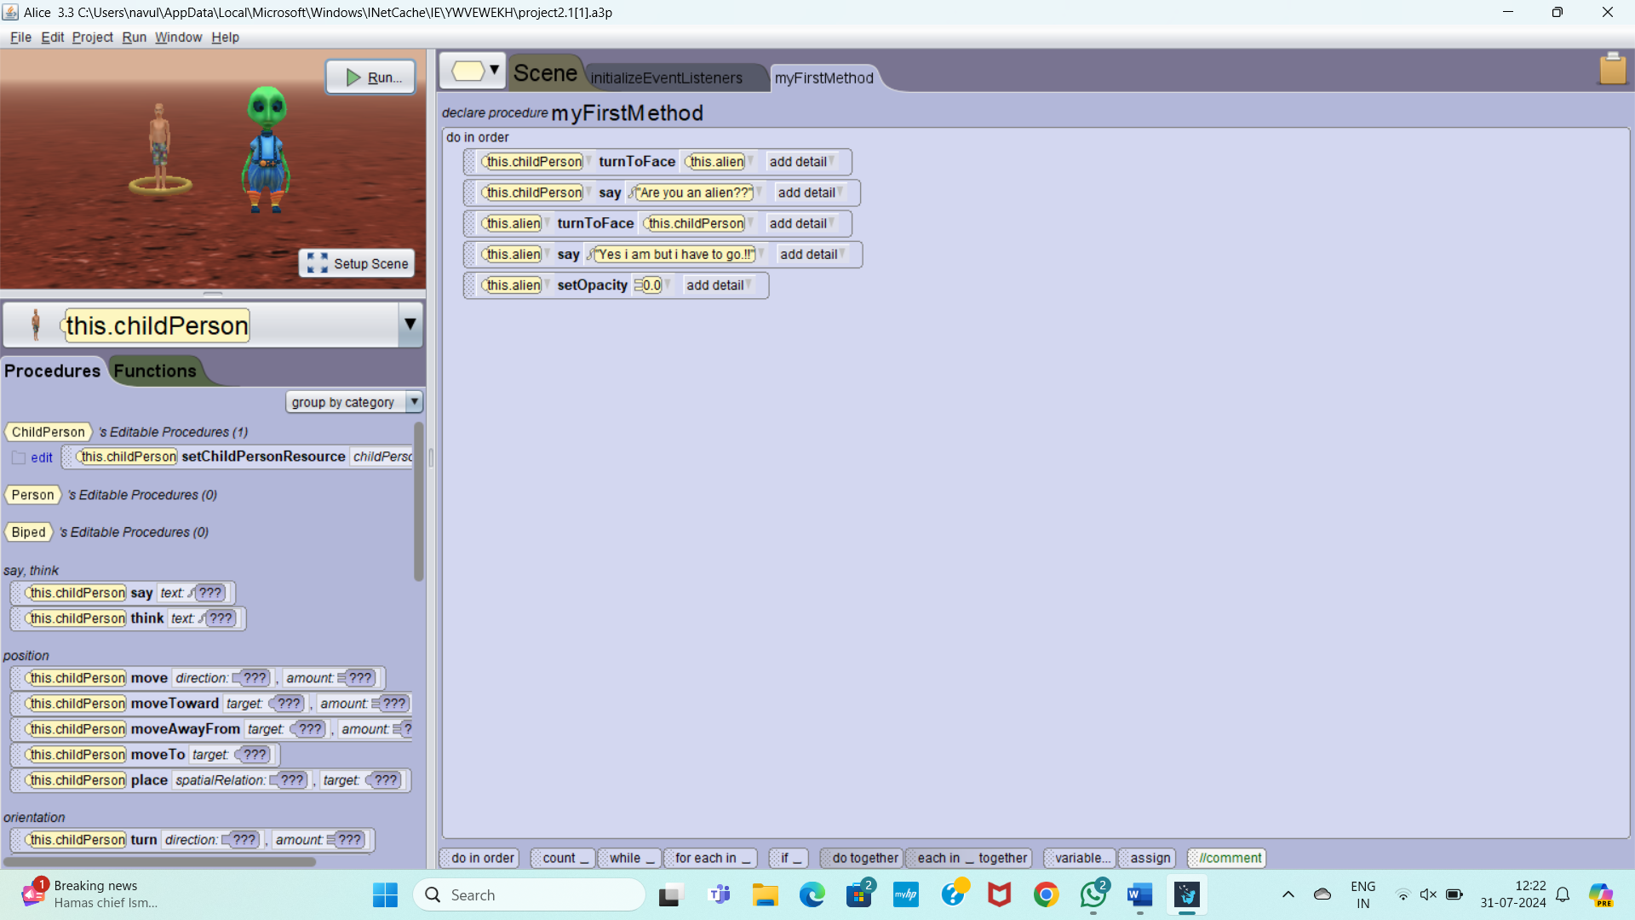

SECTION 2_2 PRACTICE

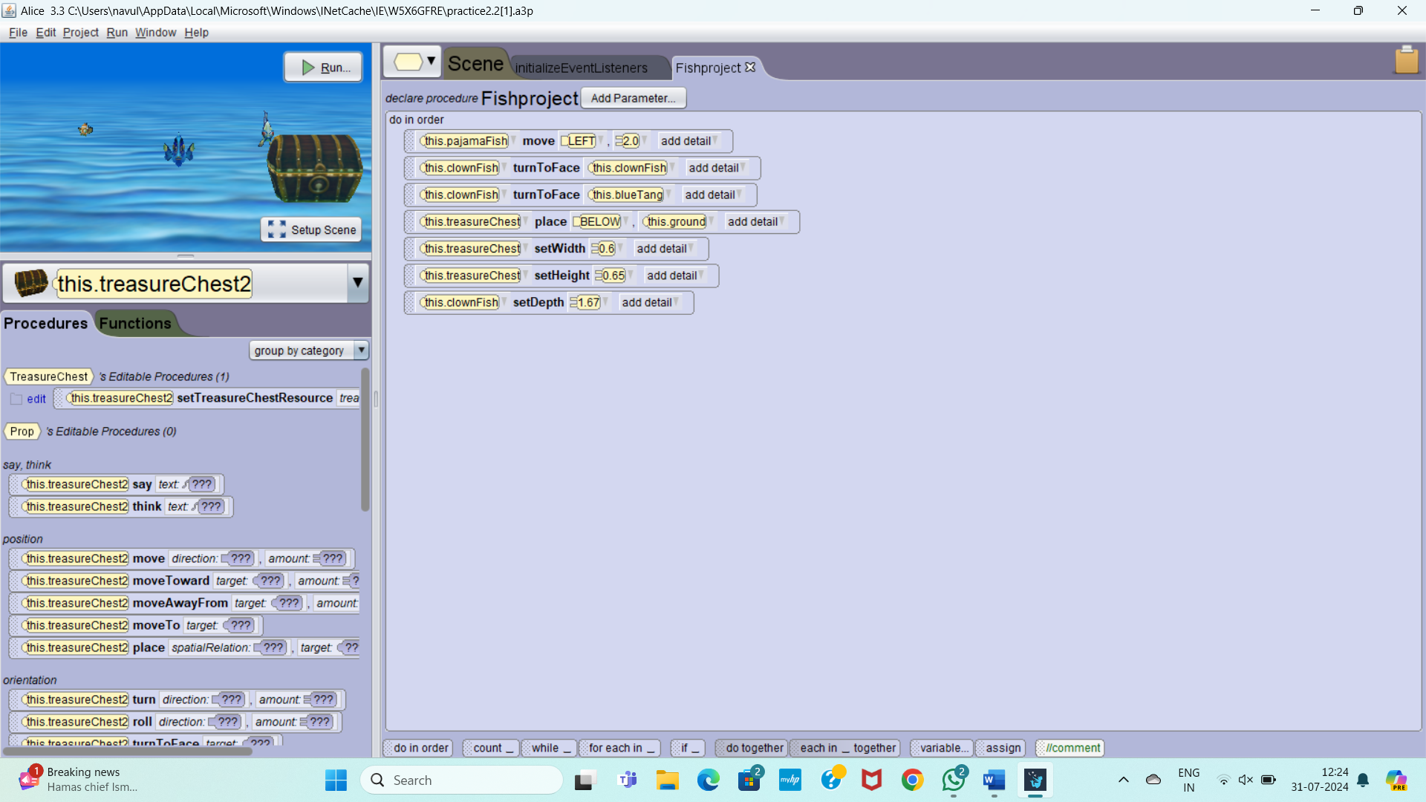

2 _2 PROJECT

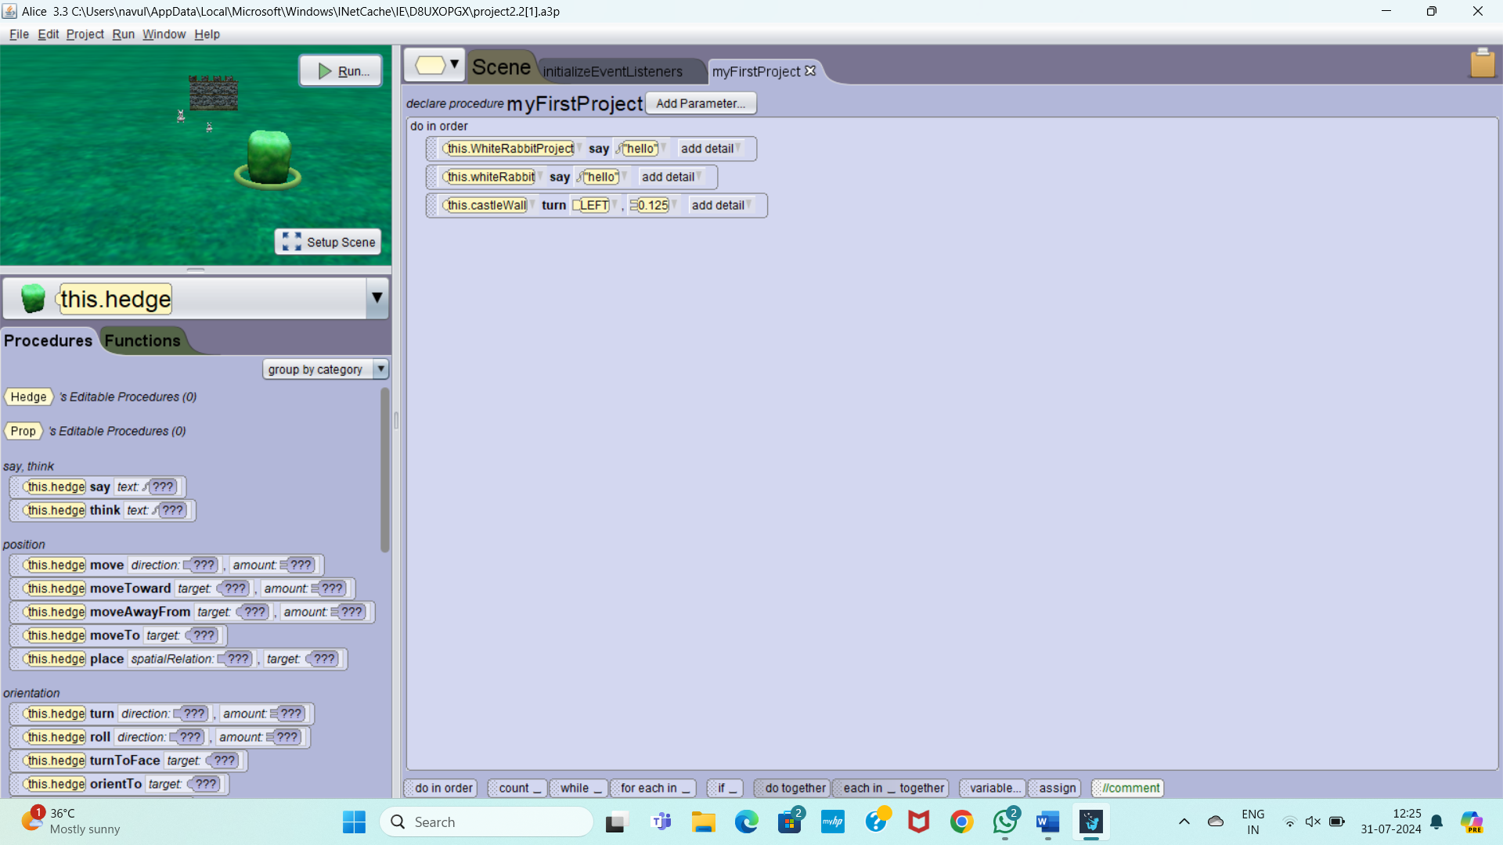

SECTION 2_3 PRACTICE

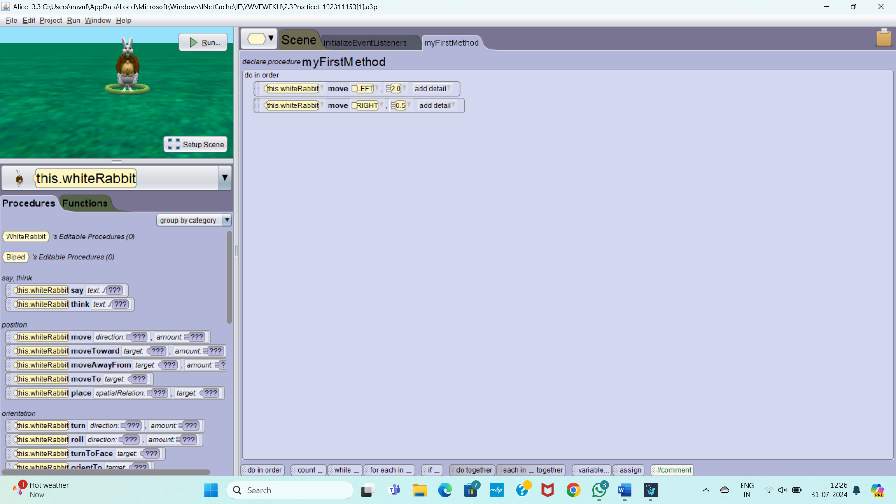

2_3 PROJECT

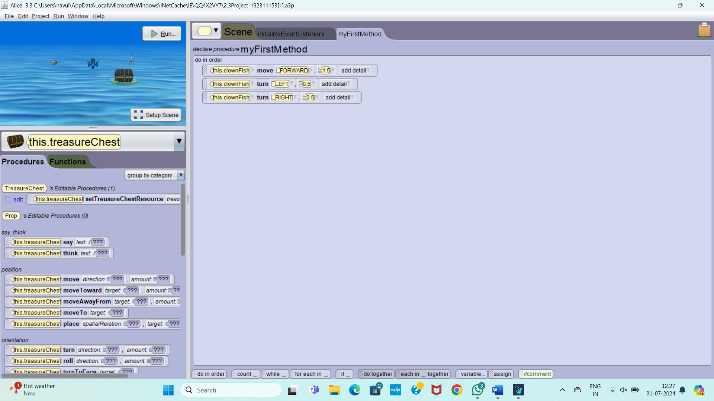

SECTION 2_4 PRACTICE

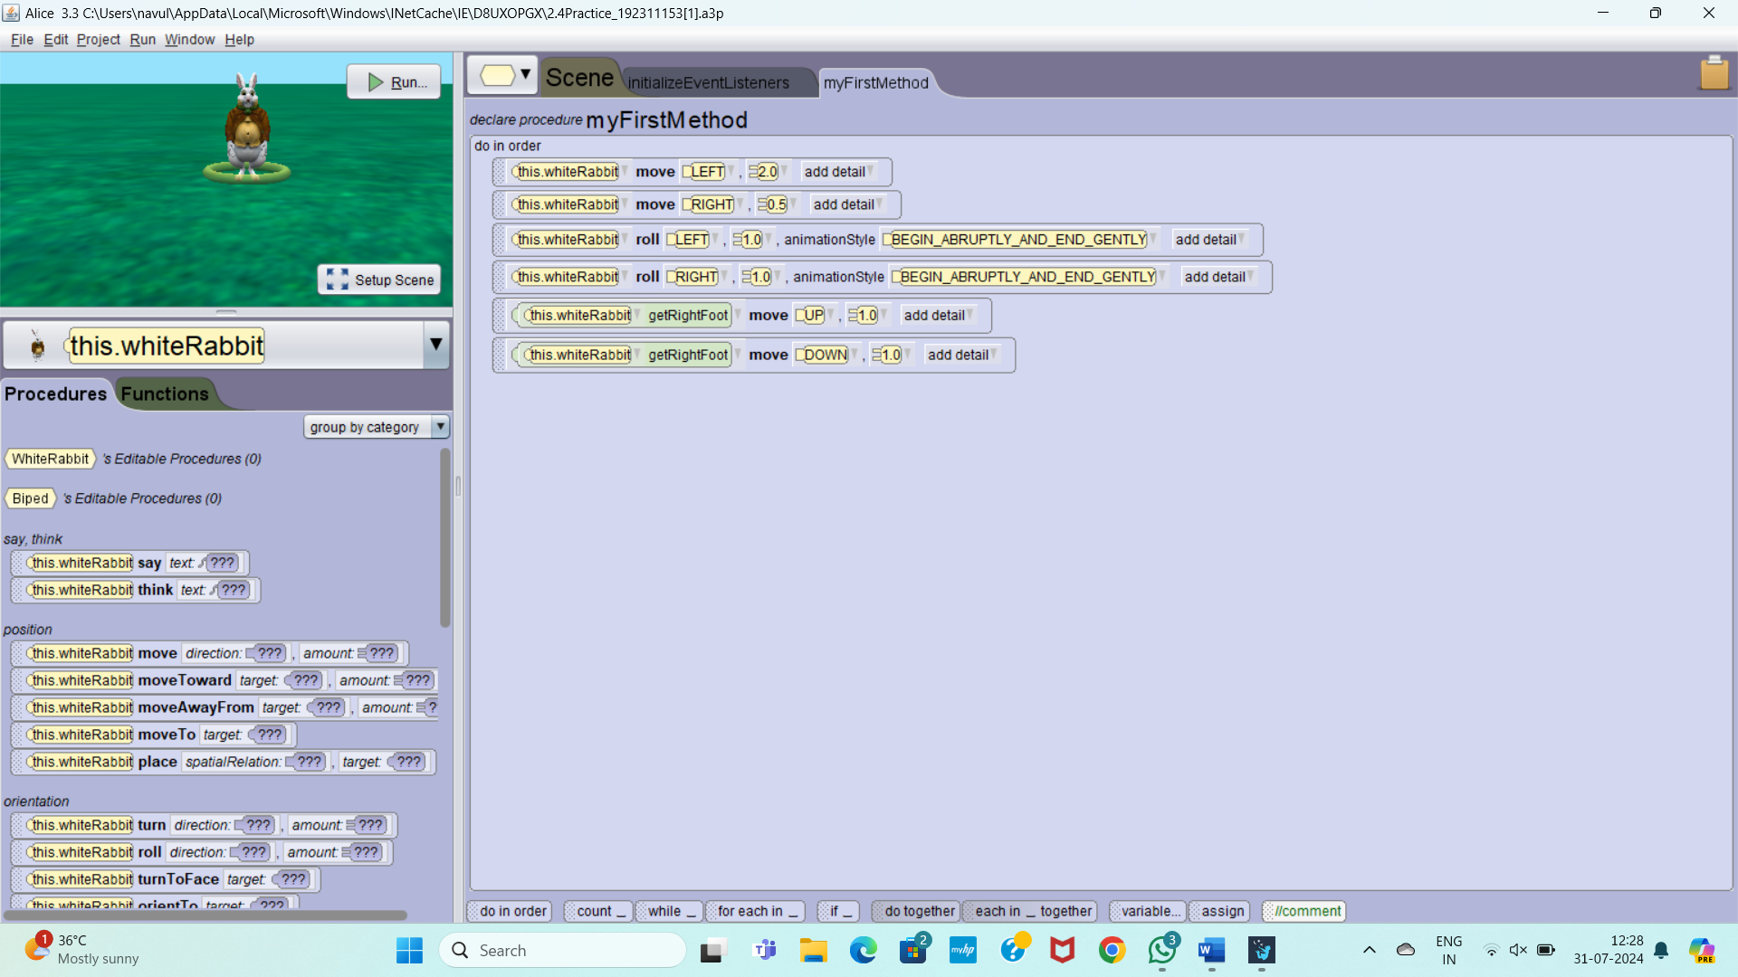

2_4 PROJECT

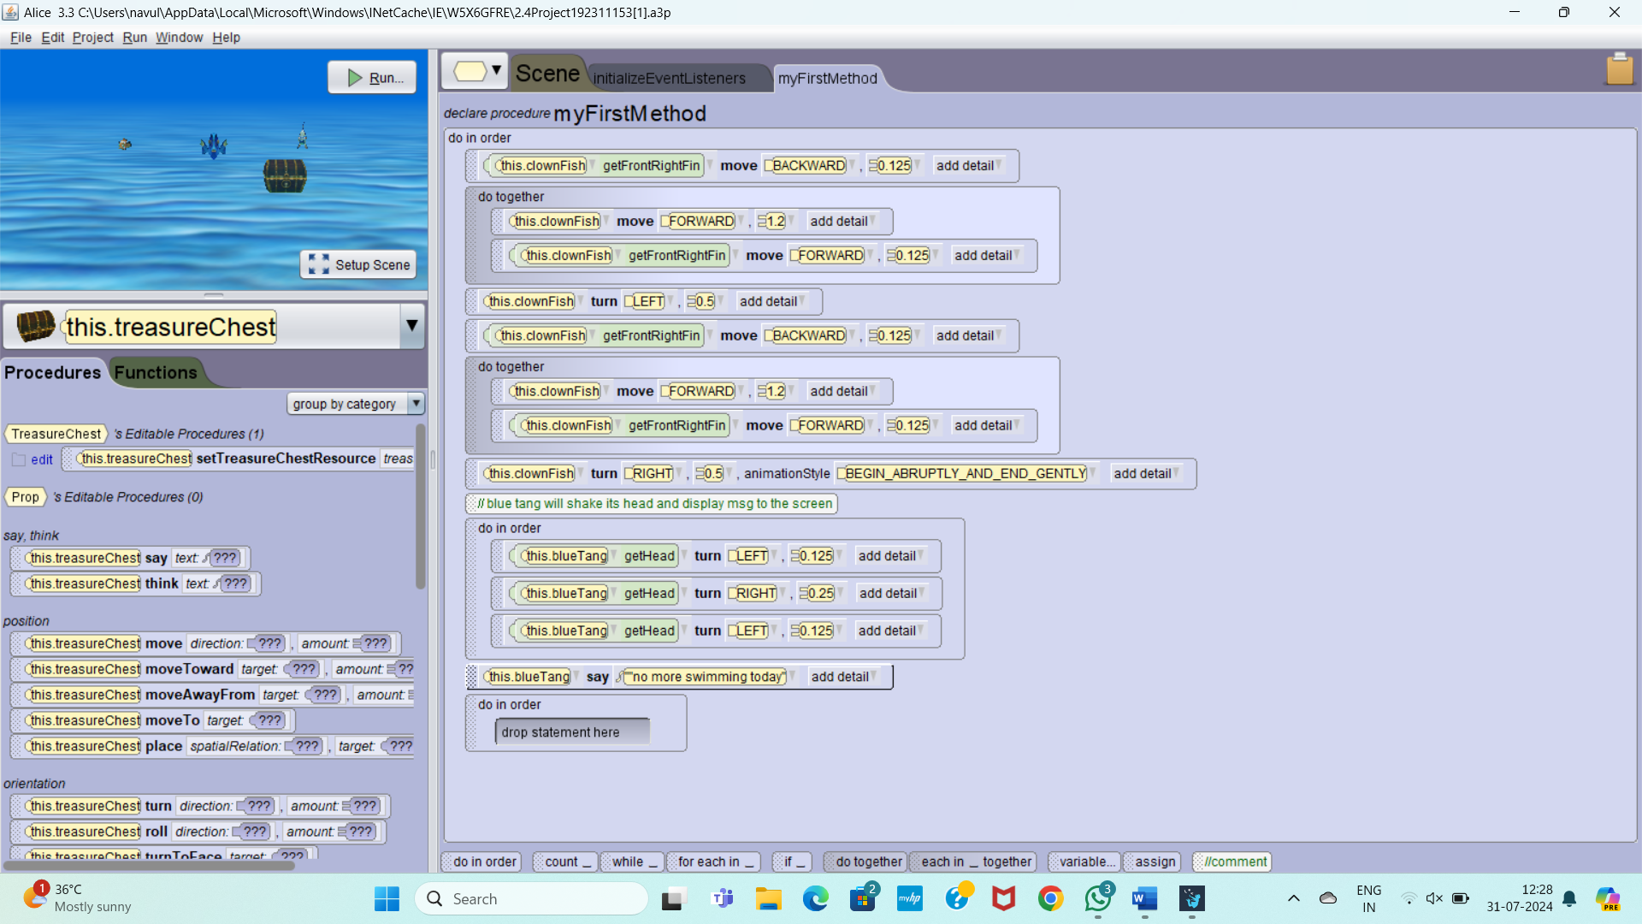

SECTION 2_5 PRACTICE

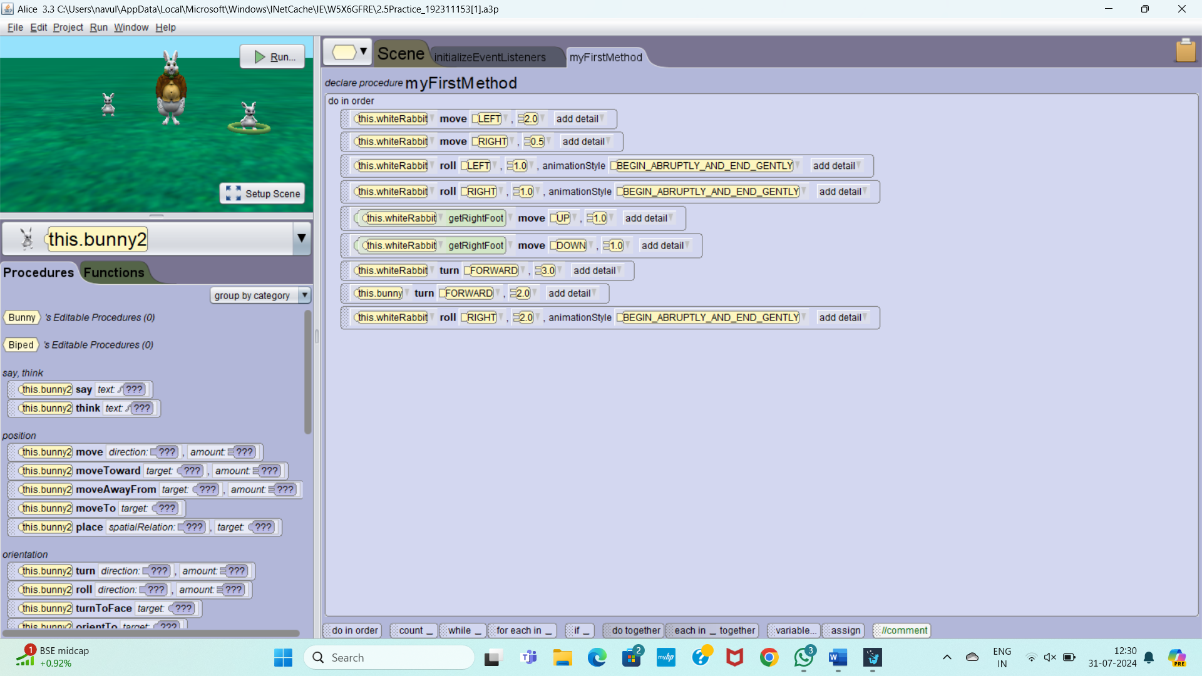

2_5 PROJECT

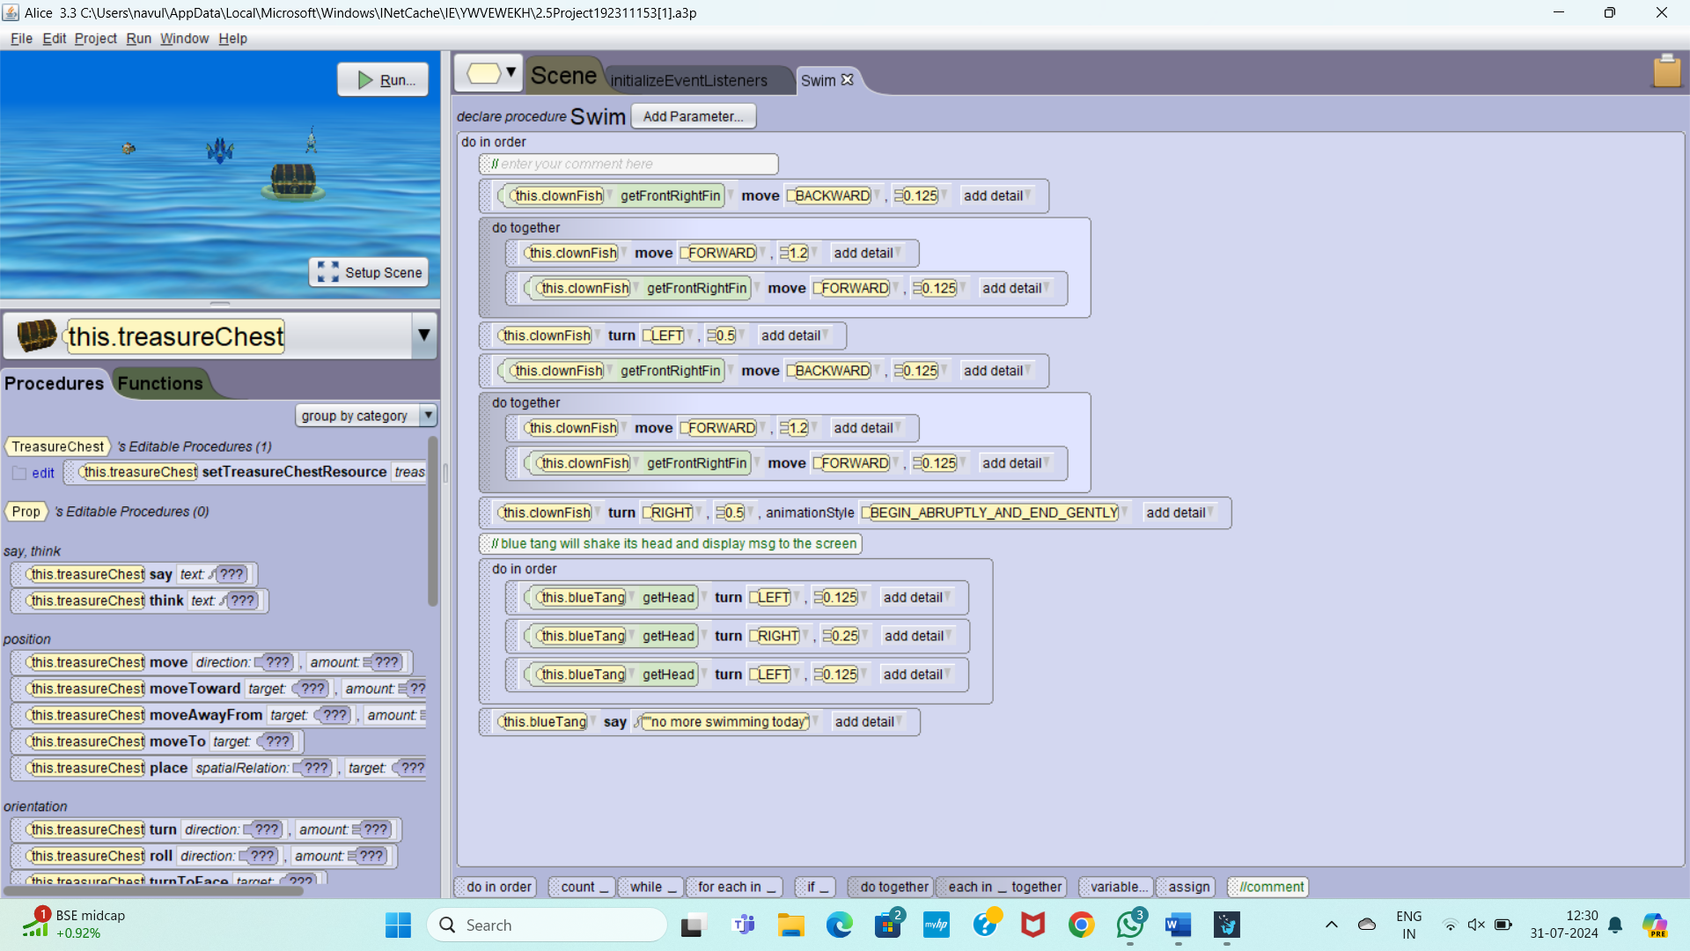

2_6 PRACTICE

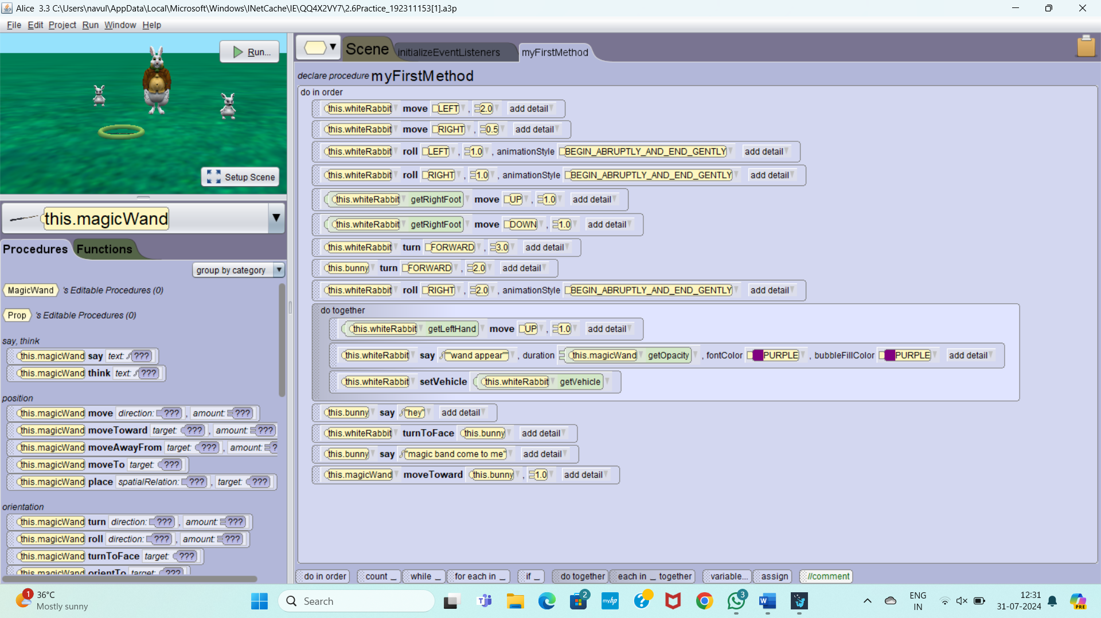

2_6 PROJECT

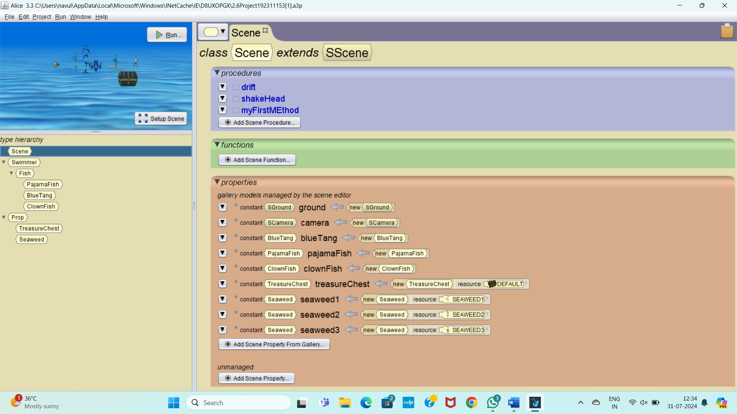

2_7 PRACTICE

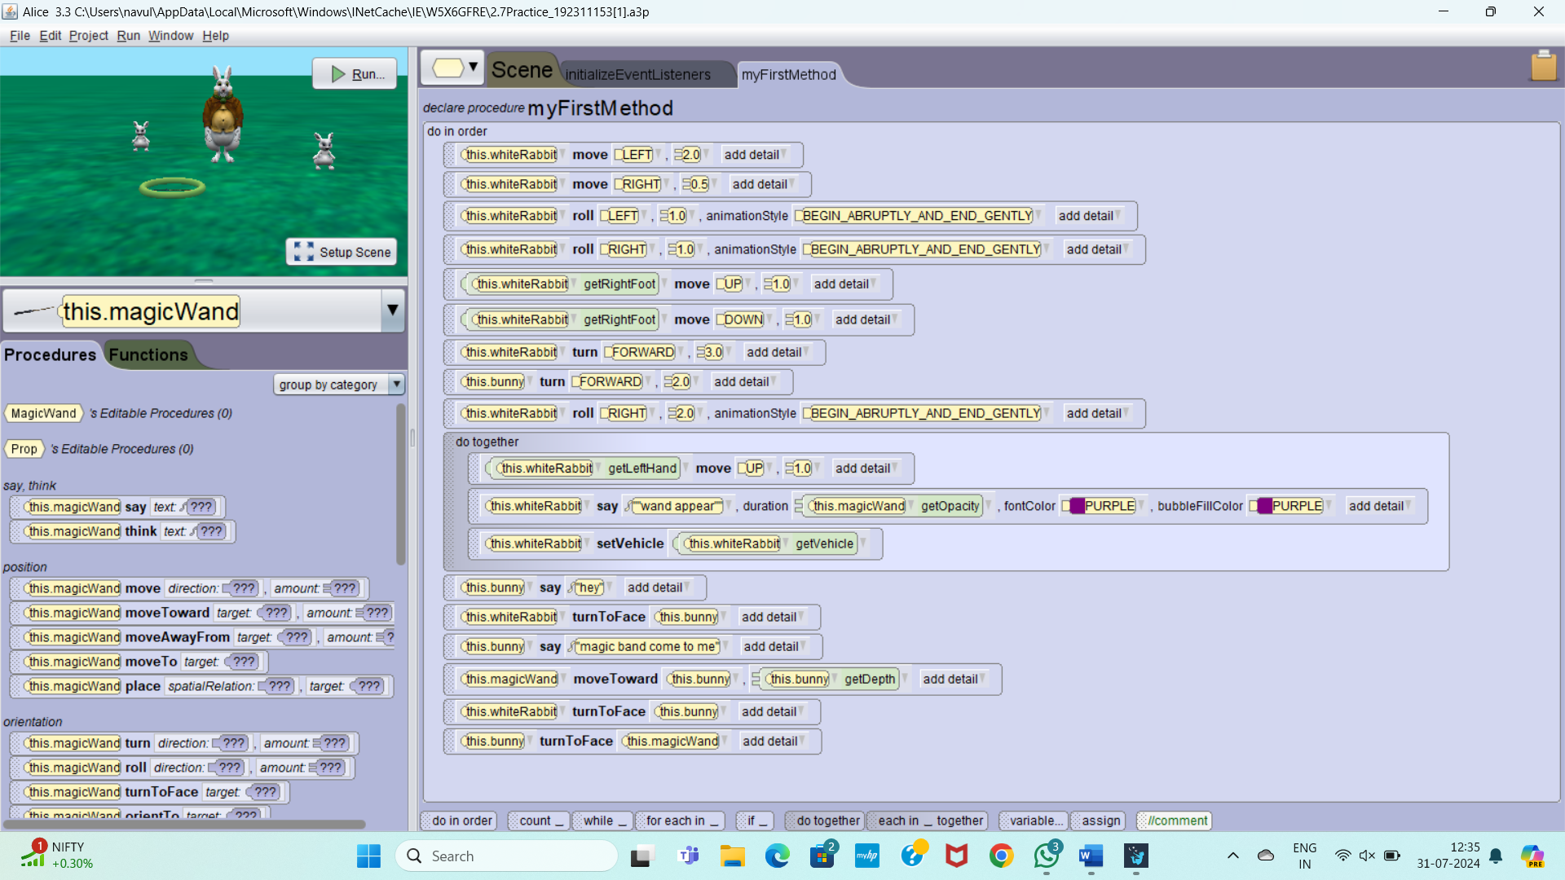

2_7 PROJECT

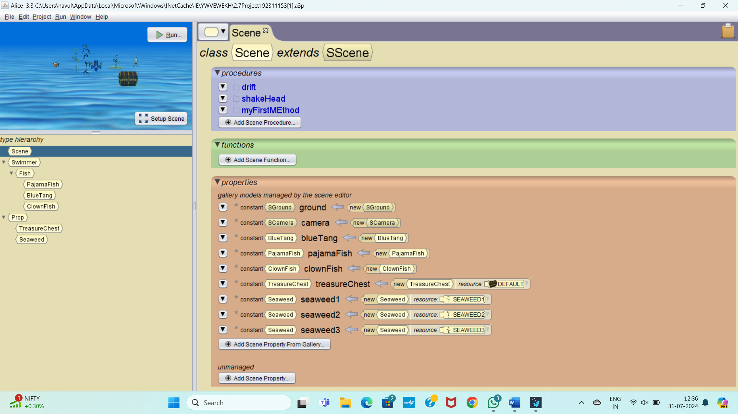

2_8 PRACTICE

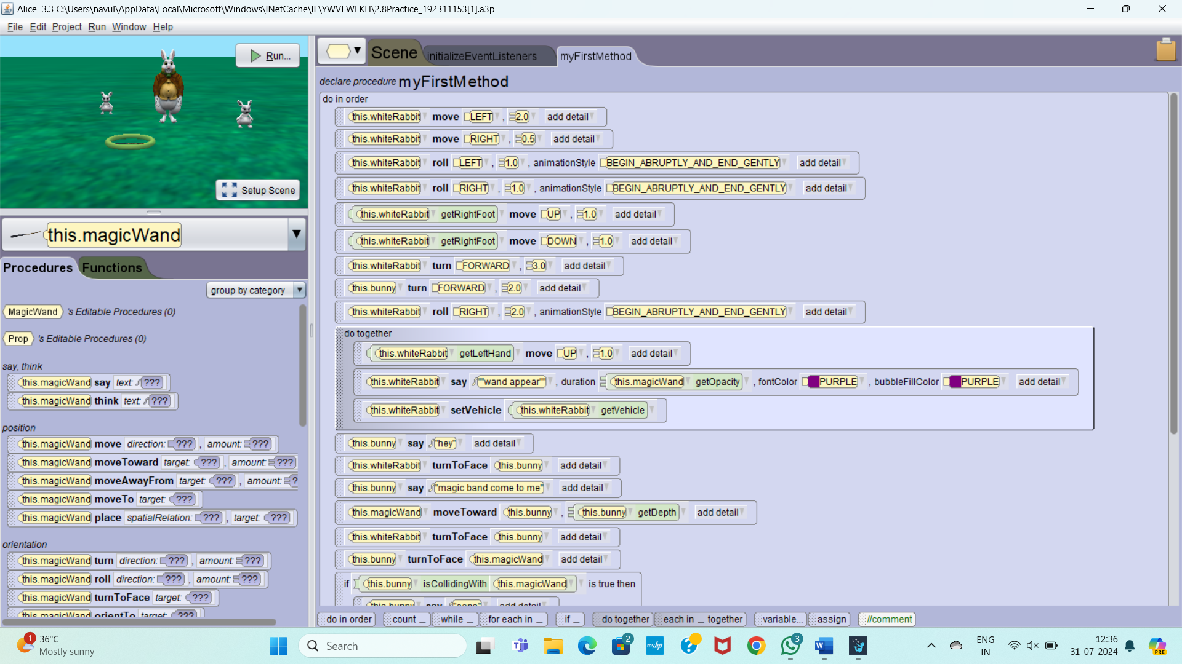

2_9 PRACTICE

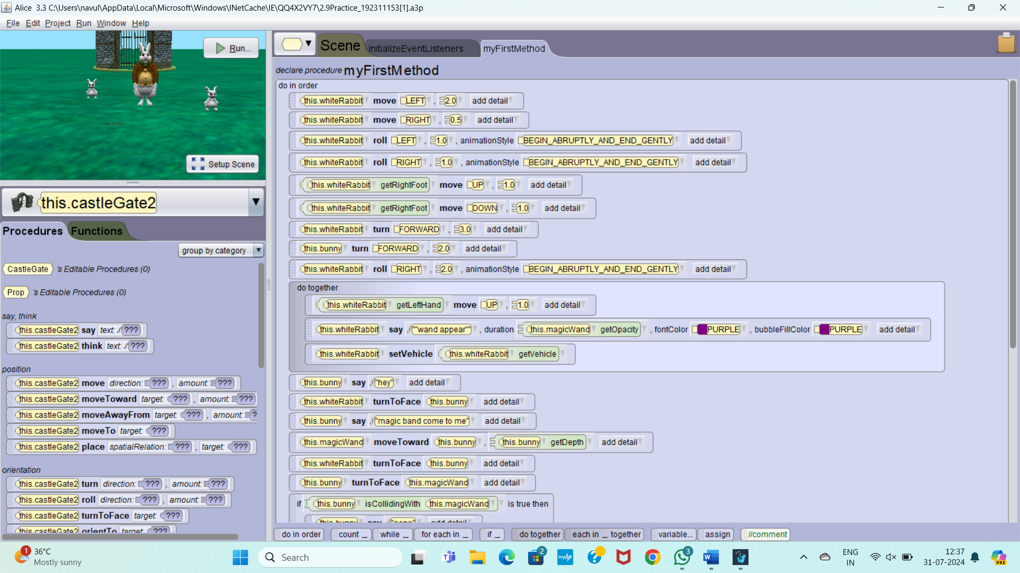

2_9 PROJECT

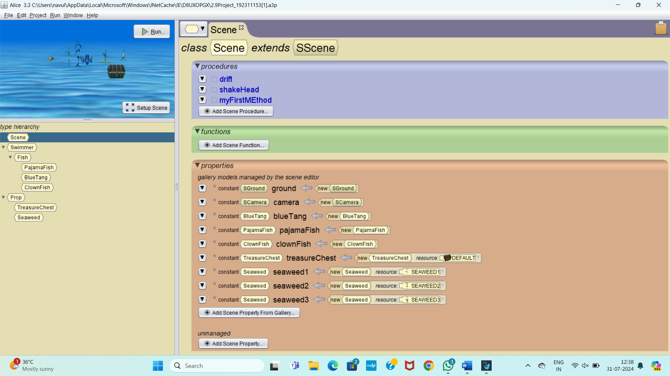

2_10 PRACTICE

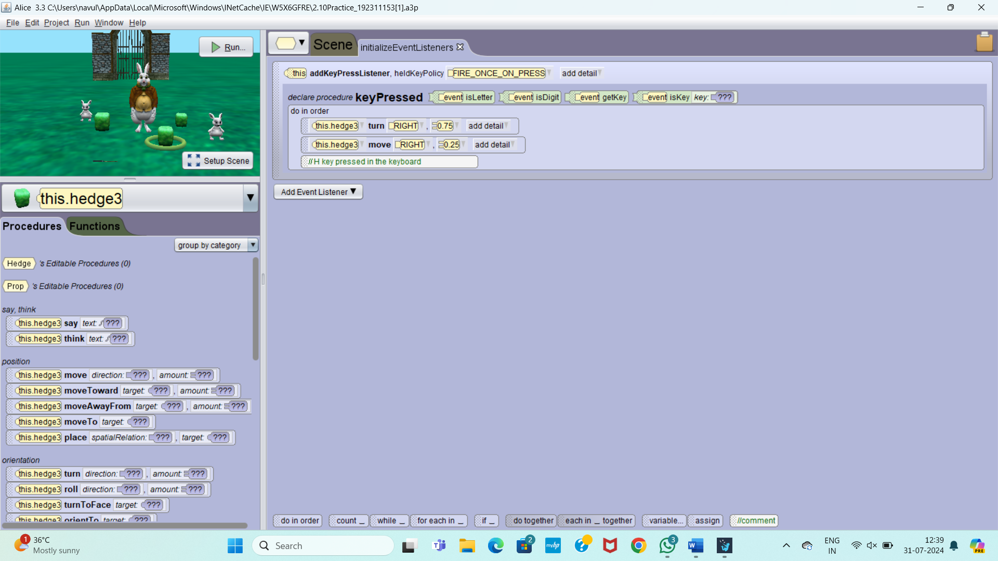

2_10 PROJECT

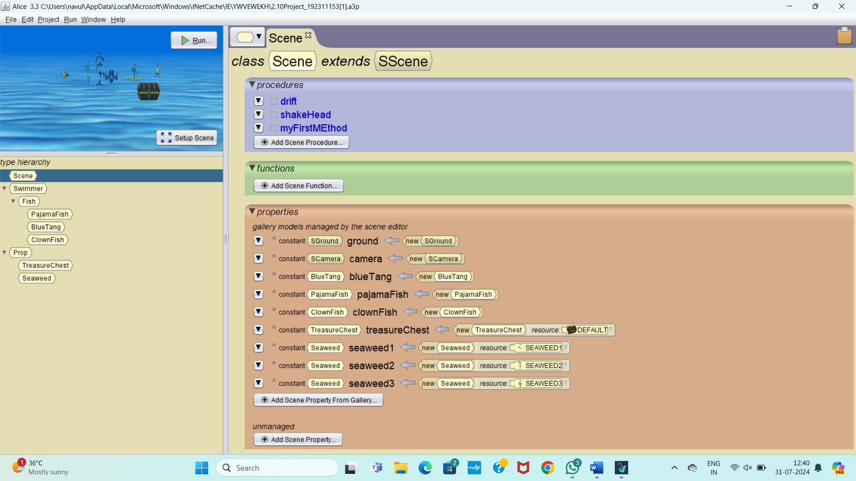

2_11 PRACTICE

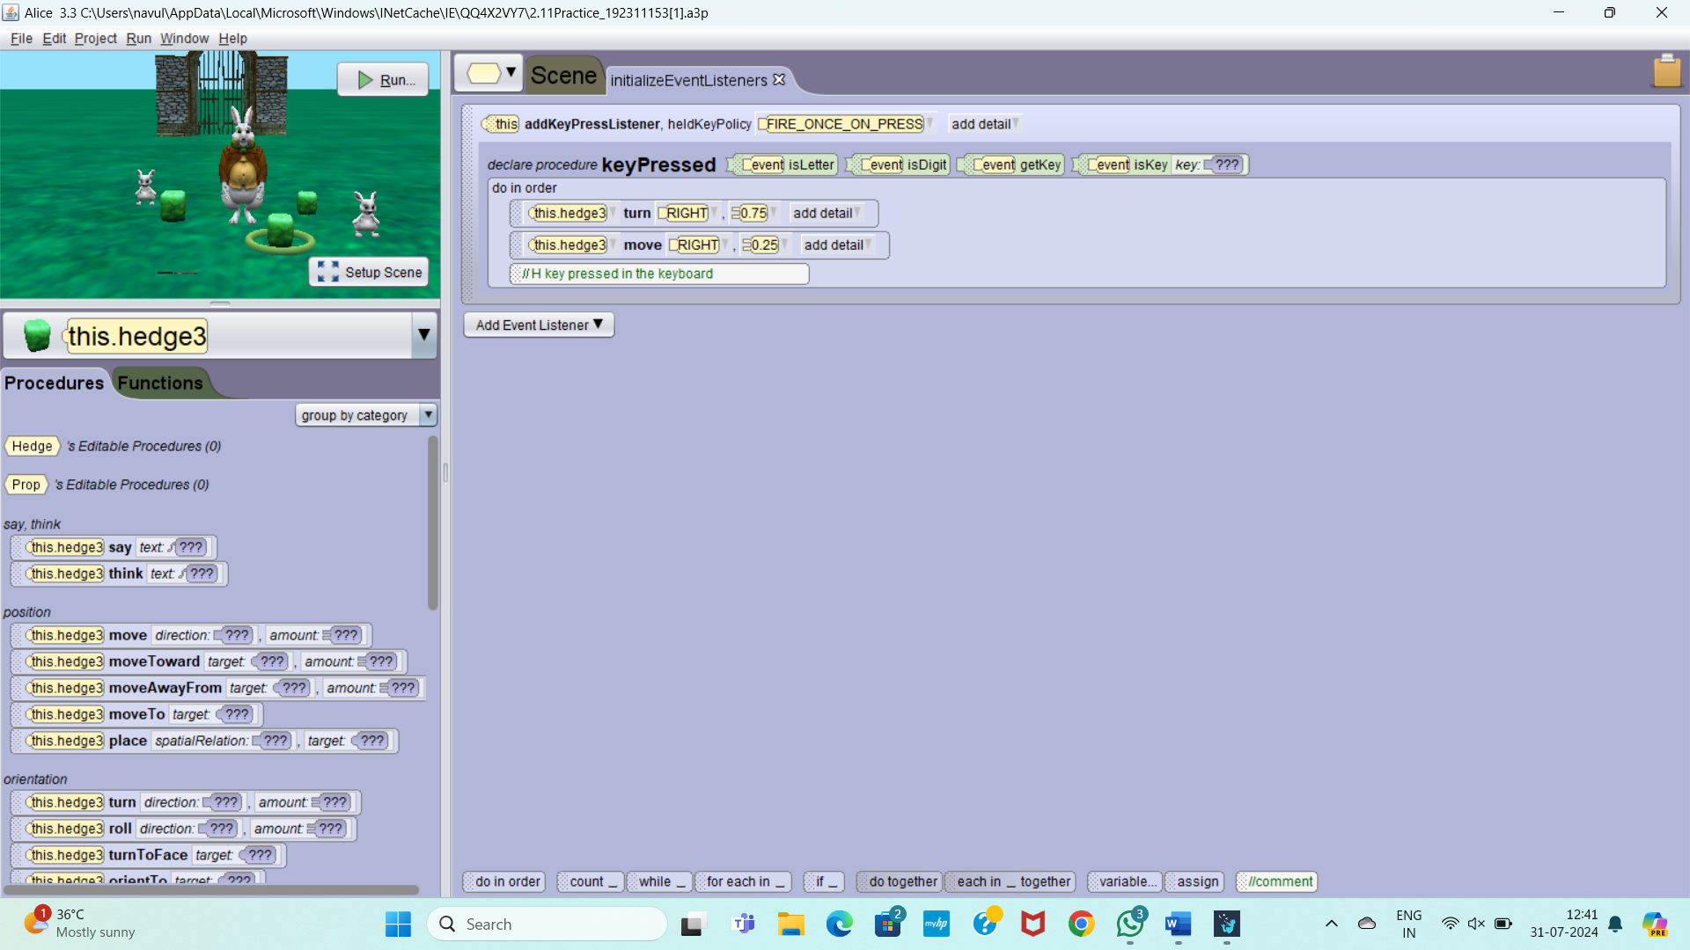

2_11 PROJECT

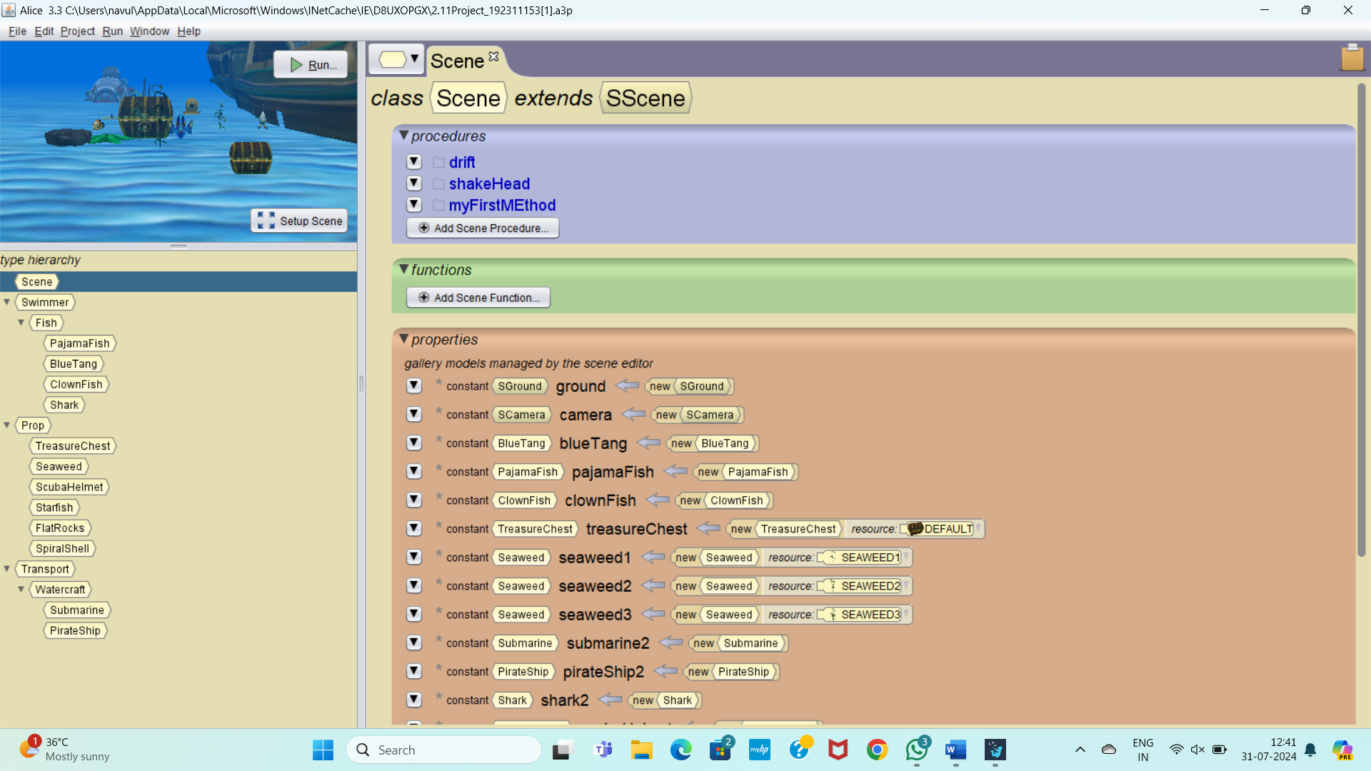

SECTION 2_12 PRACTICE

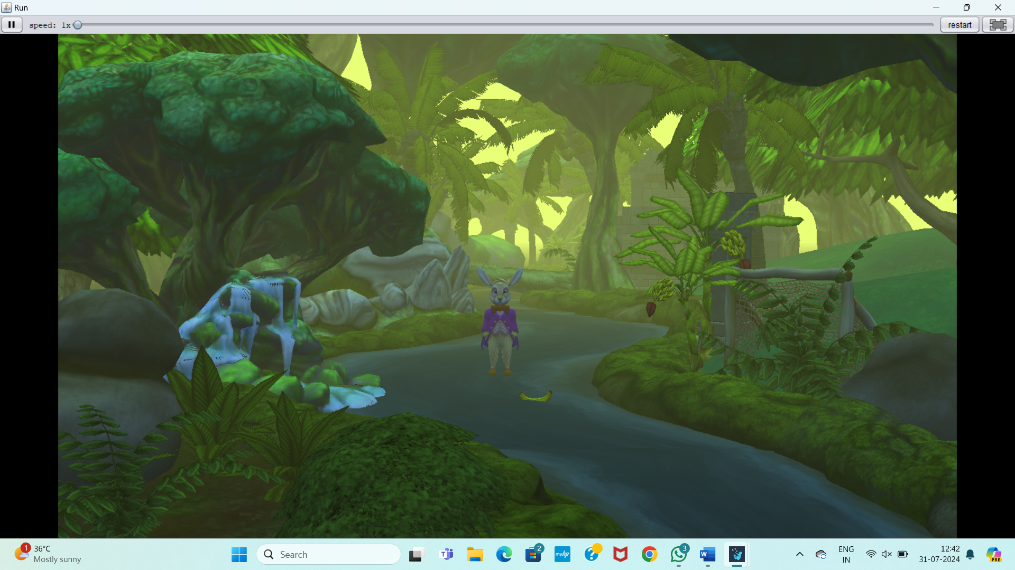

2 _12 PROJECT

